Poo Diary
Childs Name and date of birth:
Date | Time | Poo in toilet –  amount | Any soiling - amount | Type  (see poo chart on next page) | Comments | Laxatives given

Instructions for completing the Poo Diary

NHS Poo Chart  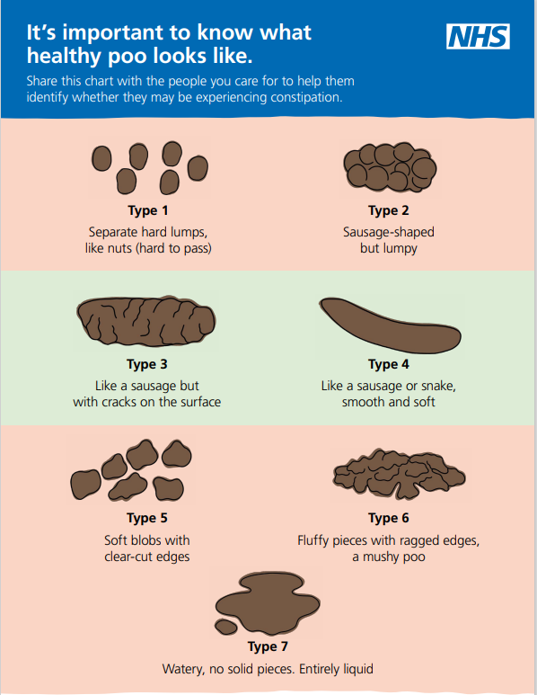 | Instructions for parents completing a poo diary  - Write down every poo that is passed, even if it is a little stain in the child’s pants.  - In the Type column, write down the number from the NHS Poo Chart that best describes the poo – see pictures on left.  - Fill in the diary for a whole week, or longer if your doctor or nurse asks for it.  - At the end of every day, check to make sure no poos were forgotten. Write in whatever laxatives have been taken that day, including the dose.  - Record the amounts of stool passed as small/medium/large etc.  - In the “Comments” column, write down anything you think may be helpful, such as if your child had tummy pain or was sick.

